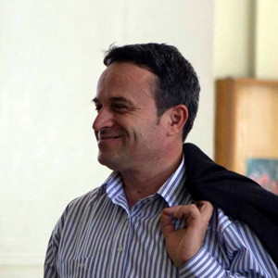

Florian Nepravishta is a professor of architecture and urbanism at the Polytechnic University of Tirana. He graduated in 1993 from the Architecture branch at the Polytechnic University of Tirana with very good results. He earned a second university degree in 2003 in Jurisprudence at the University of Shkodra with very good results. In 2002 he completed his Master of Science in Urban Housing Management at IHS – Erasmus University, Netherlands, and Lund University, Sweden. He has also completed postgraduate studies in the field of restoration and adaptation at the University of Florence in "Inner City Revitalization and Urban Renewal" at the Institute for Housing and Urban Development Studies-Rotterdam (IHS), Netherlands, and the European restoration school "Instituto per il Restauro dei Castelli", Udine-Italy. In 2009, he received the scientific degree "Doctor"; in 2013, he won the title "Associate Professor" and in 2016, he won the title "Professor" at the Polytechnic University of Tirana.

Professor Nepravishta has academic experience as a guest professor at several universities such as: Albanian University (2009 -2015), UBT (2014 – 2015), State University of Tetova (USHT), North Macedonia (2010 – 2013), Politecnico di Bari (2016), etc. He is a member of the Doctoral College "Architettura, Disegno Industriale e Beni Culturali"(Ciclo 34, Ciclo 35) Università di Campania "Luigi Vivatelli", Dipartimento Architettura e Industrial Disegno, Italy and member of the Doctoral College "Progetto, conoscenza e salvaguardia del patrimonio culturale (XXXV ciclo). Università degli Studi Firenze, DiDA, Italy.

In addition, he has participated in various scientific conferences and published scientific papers such as articles, references, and monographs. His professional opus also includes organizing exhibitions, workshops (workshops), and International Conferences (IFAU17, IFAU18, and IFAU19). He has been a member of the scientific committee of over 40 international conferences. He is a member of the editorial board of several national scientific journals (Monuments), IKM "Technical Science Bulletin," UPT) and international scientific journals ("Architecture and Urbanism," "South East European Journal of Architecture and Design (SEEJAD)," "Magazine of Civil Engineering," "JAS – SUT" Journal of Applied Sciences-SUT," etc.). Scientific director of the Forum for Architecture and Urbanism (FAU) colitis of the publishing house "La scuola di Pytagora editrice", Italy.

Various projects have marked Professor Nepravishta's professional journey as an architect. He has left his mark on the built environment, from residential to school, commercial to industrial, and tourist complexes. His expertise extends to restoring and rehabilitating existing buildings, interiors, and urban plans, showcasing his comprehensive understanding of the field.