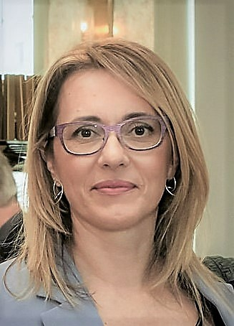

**Vlasta Zanki** graduated in 1998 from the Faculty of Mechanical Engineering and Naval Architecture, University of Zagreb (Department of Thermal Engineering). She received her master's degree in 2002 from the Kungliga Tekniska högskolan - KTH in Stockholm, and from the same faculty, she received her doctorate in 2006 from the Department of Energy in the field of energy management and energy efficiency in buildings for tourist purposes. She has also improved her skills at specialist courses, seminars, and workshops in energy efficiency, energy management, green building, and project management.

She has not just participated, but significantly contributed to 6 scientific research projects and over 15 EU and international research and professional projects. As a manager, supervisor, or associate, she has played a pivotal role in over 50 professional projects in the Republic of Croatia, showcasing her ability to lead and manage effectively. She is the author, co-author, or editor of 7 impactful publications.

From 1998 to 2007, Mrs. Zanki demonstrated her leadership potential as a junior researcher at the Department of Thermal and Process Engineering, Faculty of Mechanical Engineering and Naval Architecture. Her career continued as she was employed at the United Nations Development Program (UNDP), and from 2006 to 2008, she worked as a national consultant for HVAC systems. From 2008 to 2012, she led the Government Program 'Putting Your House in Order' through the national project 'Encouraging Energy Efficiency in the Republic of Croatia.' From May 2012 to April 2019, she served as the director of HEP ESCO d.o.o., after which she held the position of assistant director in the same company for two years. Since September 2021, she has been applying her leadership skills as an assistant professor at the Faculty of Geotechnical Engineering, University of Zagreb.

From 2015 to 2020, Ms. Zanki was the Vice President of the Board of Directors of the Croatian Green Building Council, and since December 2020, she has been the President of the Board of Directors. She participated in the establishment of the Croatian Association for Refrigeration, Air Conditioning, and Heat Pumps. Her career is a testament to her unwavering dedication to developing and implementing efficient, green, and smart innovative systems and services that contribute to sustainable development, circular economy, and environmental protection, especially in the field of energy efficiency and energy management.