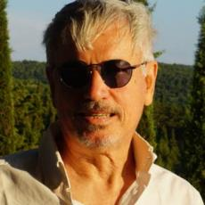

Roberto Cherubini, a distinguished professor of architecture and urban design at Sapienza University of Rome, has been leading the design studio for the fourth year of the EU curriculum in architecture since 2003. His influential leadership has significantly contributed to the future of architecture. He also serves as a board member of the PhD program in Architecture Theories and Design at Sapienza University and was the director of the International Advanced Master in Project Management of Complex Architecture from 2010 to 2016. His educational activities at all levels are aligned with his research interests, with a particular focus on harbor and coastal design. He has initiated and is leading numerous international cooperation programs in this sector. He is also the director of the esteemed magazine A&A Architettura e Ambiente.

Research Activities: Roberto Cherubini is the driving force behind LabMed, a research laboratory on design for Mediterranean areas at the Department of Architecture and Design (DIAP) of Sapienza University. LabMed oversees the research work of numerous international cooperation programs, all initiated by Roberto Cherubini. These programs primarily focus on harbor and coastal design and have recently expanded to include architecture and archaeology, architecture and heritage, and architecture and sustainable urban development. Roberto Cherubini is currently managing international cooperation protocols with Serbia, Montenegro, Morocco, St Petersburg in Russia and Azerbaijan and direct cooperation programs with Crete and Turkey, showcasing the global reach of his research.

Professionals Activities: Roberto Cherubini established CSIAA (www.csiaa.it) in 1999, a design office intended as a think tank for architecture, urban, and landscape design. It can work out of the common Highline and accompany its design activity with individually structured public debates, research, and publications. Since 2000, when it was called in Hanover by Workshop Expo 2000, laying out a form for the sustainable future of the world fair field and buildings, CSIAA has worked innovatively, mixing the different design scales of landscape, town, and architecture. CSIAA_Docks Reloaded, the report on CSIAA projects on coastal design published in 2007, was presented in the same year at GSD Harvard.

