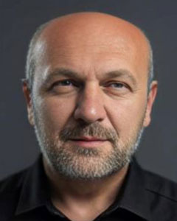

**Professor Amir Čaušević's** profound impact on the field of historic structures is evident in his extensive body of work, which he began in 2000 with his master's on "Structural aspects of repair and reconstruction in case of masonry structure" and continued with his groundbreaking PhD on "Architectural and structural conceptions of sacral object's towers -Behaviour under atypical actions" by 2009.

Professor Čaušević's work has garnered international recognition, with him being the author of about 75 international and national papers, books, and chapters in books, primarily focusing on preserving and evaluating historic structures. His editorial work for the Hazards & modern Heritage International Conference in Sarajevo further solidifies his standing in the academic community. He is a respected Member of the ISCARSAH Committee, the International Masonry Society -IMS, the Technical Committee BAS TC 58, and an Expert member of the International Council on Monuments and Sites –ISCARSAH(ICOMOS).

Professor Čaušević's leadership and mentorship in the field of historic structures is a testament to his influence. He has undertaken important tasks, contributed to international projects, and visited cities for training in professional interests: Berlin University, Stuttgart University, Trieste University, Istanbul Yildiz University, Jerusalem, Bari Politecnico, Ankara Middle East Technical University, Rome La Sapienza University, and Istanbul Technical University. He has been leading many graduate students and working on structural analysis of historic structures. He is an especially useful member for various sub-committees, organizing international groups, and collaborating with colleagues.