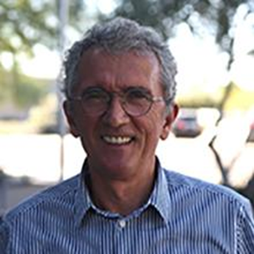

**Dr. Shahin Berisha** is an Arizona State University's Melikian Center adjunct professor. He has over 40 years of experience teaching and conducting research in the engineering field, both in Kosovo and the United States. His most recent research focuses on estimating the human impact on climate change. He has authored or co-authored over 50 journal and conference papers, along with several engineering handbooks and textbooks.