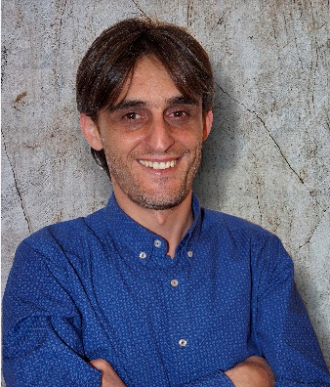

**Nuran Saliu** (born March 4, 1980, in Gostivar) is an architect and academic. He graduated in 2003 with a degree in architecture from the Polytechnic University of Tirana. He holds a Master’s degree from “La Sapienza” University in Rome (2009), focusing on healthcare facility planning, and a PhD from the Polytechnic University of Tirana (2019) with a dissertation on automated design methods in hospital buildings.

Since 2020, Nuran has taught architectural and computational design studios as an Assistant Professor at the State University of Tetovo. He previously served as an assistant lecturer and an assistant, contributing to the university’s architecture program since 2007.

Nuran has extensive experience in architectural design and managing diverse construction projects. He is a Co-Founder of EN:A Office for Architecture and Interior Design based in Tetova, North Macedonia.

Nuran is an active member of the architecture and design community. He is a proud member of the Macedonian Association of Architects and the Chamber of Authorized Architects of North Macedonia, where he actively contributes to the professional development of the industry.