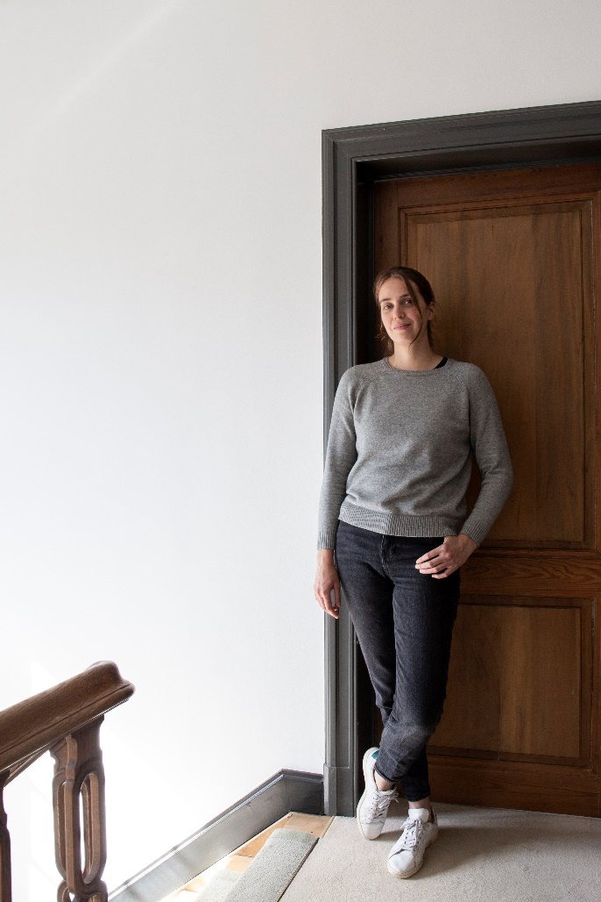

As a partner at RealVisuals, a company distinguished for its innovative approach to 3D surveying, **Aziliz Vandesande** is part of a team of creative, down-to-earth experts. Their unique approach not only understands the benefits and opportunities of accurate data in construction and restoration projects but also the risks of oversimplified representations or excessive information. The chance to be creative (think alpinism!) and to utilize cutting-edge technologies (like SLAM, AI, or gaming engines) makes RealVisuals an ideal working environment for her!

As a guest professor at KU Leuven, she coordinates and teaches a highly specialized course on built heritage documentation. Through lectures and hands-on survey exercises, students gain knowledge and experience in documenting the reality of existing buildings and built heritage sites characterized by complex geometries, different layers of interventions, and changes in constructive systems.

How she got here… She graduated with a Master's in Conservation of Monuments and Sites from the Faculty of Engineering Science of the University of Leuven. She developed her passion for documenting heritage assets while interning at the UNESCO office in Amman (Jordan). In 2017, following four years of research on monitoring built heritage, she obtained her doctorate in Civil Engineering from the University of Leuven.

She successfully set up and coordinated several EU and international R&D projects throughout her career, demonstrating her ability to work in diverse cultural and geographical contexts. As the scientific coordinator of a 2.9 million euro H2020 project, she gained a wide variety of valuable skills for running and managing challenging projects and bringing them to a fruitful close for different donors, partners, and stakeholders. She learned the value of understanding the unique and specific needs of each heritage building or site by successfully carrying out projects and capacity building in the Middle East, Sub-Saharan Africa, North Africa, South America, and the Western Balkans.

Like any “good” academic, she has presented her results at international conferences, published several articles, and edited books. She is also a member of several active networks, e.g., the OurWorldHeritage committee for the transformational impacts of information technology. Throughout her journey, she has always been an ardent admirer of MOMO architecture, a passion that has enriched her professional life.