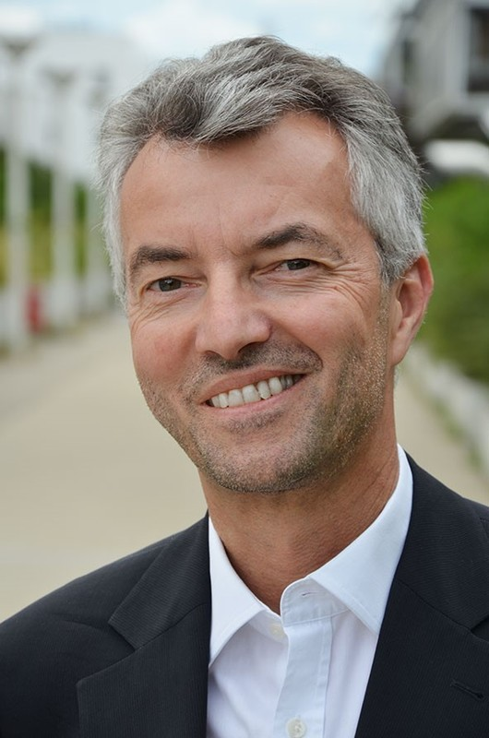

**Ao. Univ. Prof. DI Dr. Andreas Voigt** studied spatial and regional planning at TU Wien, where he was awarded a doctorate with distinction (sub auspiciis praesidentis) and was subsequently appointed Associate Professor of Local Planning. His research and teaching activities focus on sustainable urban and regional development, inward and integrated regional development, and spatial simulation and its theoretical foundations.

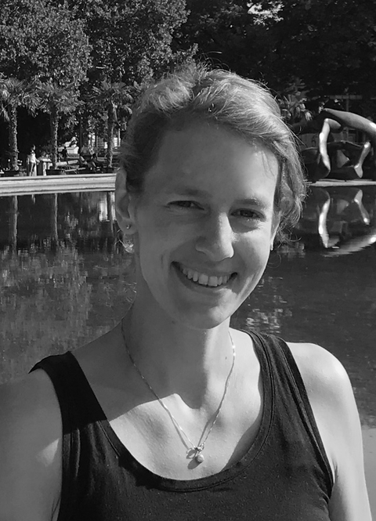

**DI Dr. Julia Forster** is the head of the Spatial Simulation Laboratory (Simlab) at the Research Unit of Local Planning. Julia is an architect and spatial planner who focuses on digital planning and decision-support tools for resource-conscious development. In that context, she works on spatial data analysis and holistic system visualization for agile collaboration of interdisciplinary experts within national and international research projects. For her PhD as part of the interdisciplinary doctoral college URBEM (development of robust scenarios for the future city of Vienna), she was awarded the Ressel Prize in 2017.