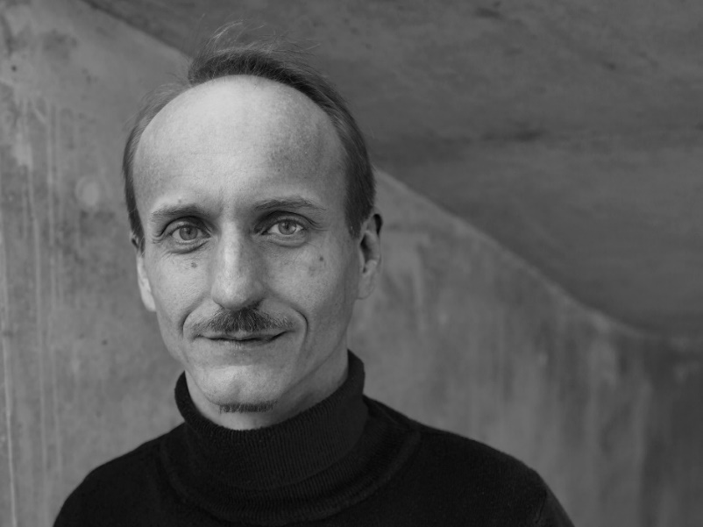

Tenure-Track Professor **Thomas Wortmann** directs the Department of Computing in Architecture at the Institute for Computational Design and Construction (ICD/CA), University of Stuttgart. He holds a Master of Architecture from the University of Kassel, a Master of Science in Design and Computation from MIT, and a PhD in Architecture and Sustainable Design from Singapore University of Technology and Design. Before joining ICD, Thomas was a lecturer at Xi’an Jiaotong-Liverpool University in Suzhou, China. He researches using computational methods such as optimization, multi-variate visualization, and machine learning in architectural design processes. He leads the development of Opossum, a machine-learning-based optimization tool that has been downloaded over 15.000 times.

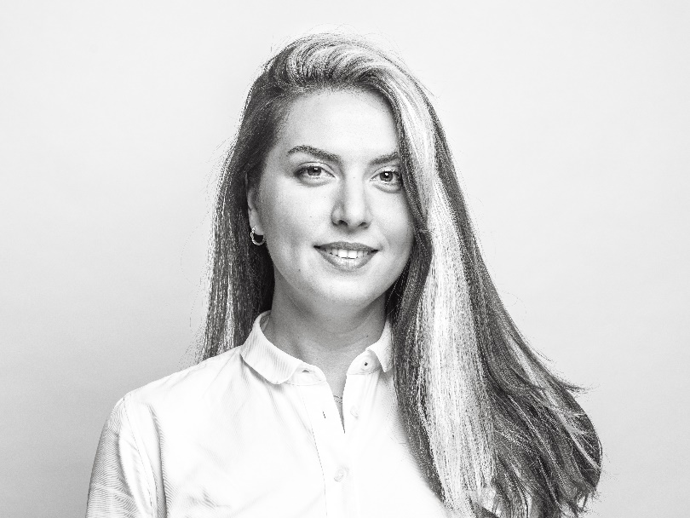

**Diellza Elshani** is a lecturer, research group leader for knowledge graphs in architecture, and a doctoral candidate at the Department for Computing in Architecture (ICD/CA) at the Institute for Computational Design and Construction (ICD), University of Stuttgart. She holds a Master of Science in Integrated Urban Development & Design from the Bauhaus University of Weimar and a Bachelor of Architecture from Mimar Sinan Fine Arts University in Istanbul. Before joining ICD, Diellza was a researcher at the City Intelligence Lab (CIL) of the Austrian Institute of Technology (AIT), focusing on cognitive urban design computing. She has garnered architectural experience in Germany, Austria, Turkey, and Kosovo. Diellza's primary research interest lies at the intersection of Symbolic Artificial Intelligence and Building Information Modeling, specifically focusing on knowledge graphs and Semantic Web technologies. She has over 10 publications on digital methods in the building industry, including conference proceedings and book chapters.