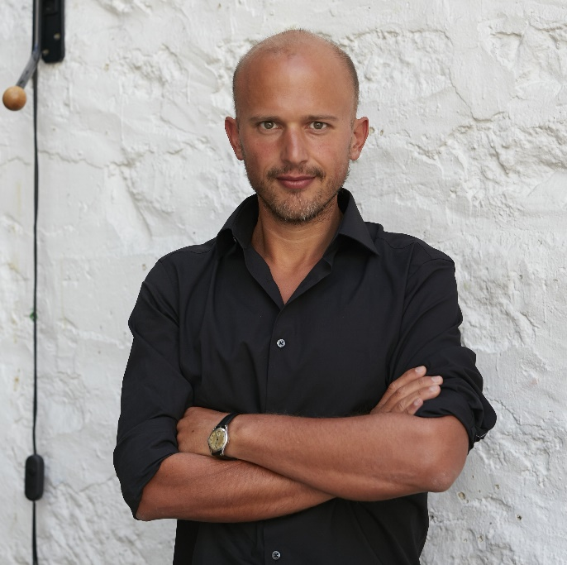

**Clément Blanchet** is a French architect, teacher, and critic who actively practices in the fields of architectural theory, urbanism, and cultural investigations.

He founded Clément Blanchet Architecture (CBA)in May 2014 in Paris after studying and living/working internationally for more than 15 years. The practice is structured as a laboratory, researching, informing, and generating architecture/urbanism in all its forms.

In July 2017, Blanchet was appointed chief architect of the Annecy area (FR).

The office activity reflects the international experience: from being invited to international competitions in the USA, Asia, and Europe to designing a master plan and a hotel complex in Tbilisi (Georgia) and new urban development in Shenzhen (Asia)and Shanghai.

In March 2021, Clément Blanchet Architecture was awarded winner of the International anonymous competition for the Sicilian Headquarter in Palermo (IT – with Leclercq and Laisné)

In France, the office has been focusing on education issues through several winning competitions: the Innovation Campus in Antony (FR) (2017) and the Carrefour Research And Development Center Saclay (FR)(2017). Recently, the agency won an international competition to create a 1,500-seat auditorium as part of the Grand Paris.

In June 2019, CBA won the construction of the 15,000-seat new BAUER stadium in Saint Ouen (FR) with Scau.

Clément Blanchet is leading Urbanist in charge of Metz urban development in METZ since 2020 (Zac Amphitheatre)

After studying architecture at the AA School of Architecture in London, the Chulalongkorn Mahawitthayalai Architectural School in Bangkok, and the University of Illinois in Chicago, he graduated with high honors from the Architectural School of Versailles.

He started working at OMA in 2004, became an associate in 2008, and director of OMA France in 2011.

During his 10 years collaborating with Rem Koolhaas, Clement contributed to the development of OMA in France and led several winning projects for the firm, including the construction of Serpentine Gallery in London, the design and construction of Caen Library (completed 2017), the design and development of winning entries like the Convention and Exhibition Centre in Toulouse (completed 2020), the Engineering school of Centrale (completed 2018), master plans in Saclay and Bordeaux, and lately the bridge Simone Weil over the Garonne in Bordeaux (to be completed in 2024).

Clement Blanchet has always been interested in the bridges between theoretical approach and pragmatism in architecture.

He has been an invited critic to architectural schools in France, England, Holland, Denmark, and Sweden. He has taught at Taubman College since 2014 (Michigan, USA) and is currently at the Bauhaus (DIA—Dessau)and Paris Malaquais Architectural School (Paris).